- If you know the class number for each class you wish to schedule, you’ll be done quickly!

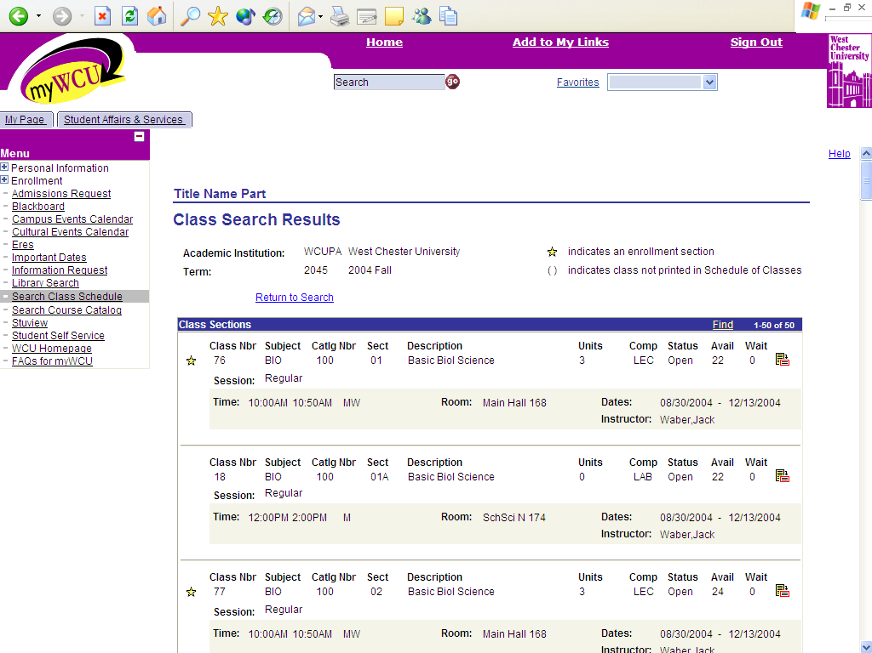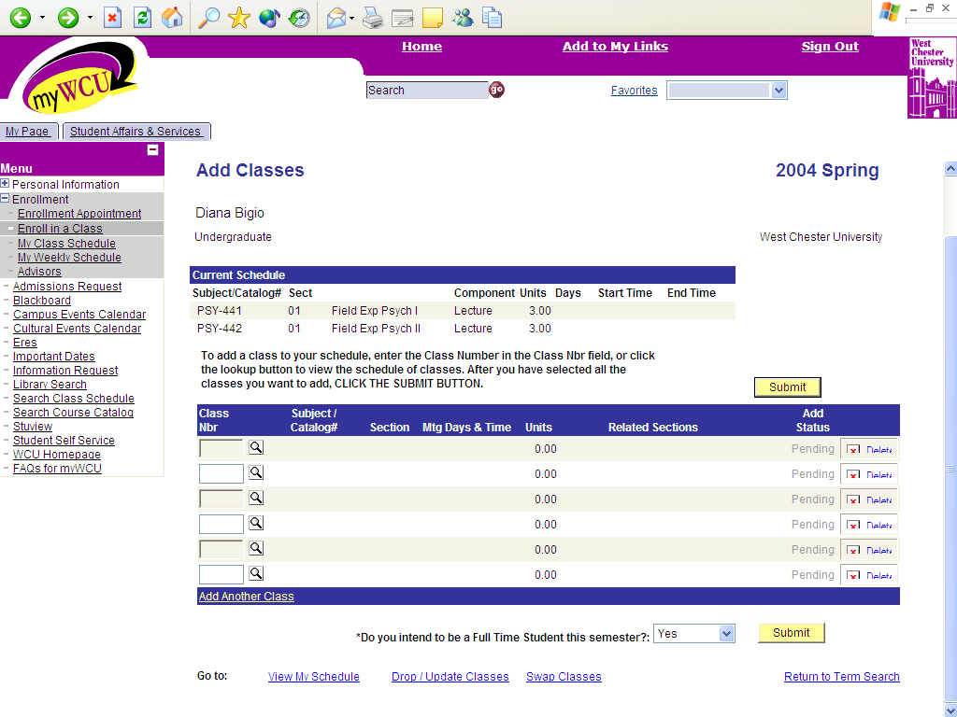

- Click on the SUBMIT button to finalize your schedule after you Add, Drop or Swap classes! 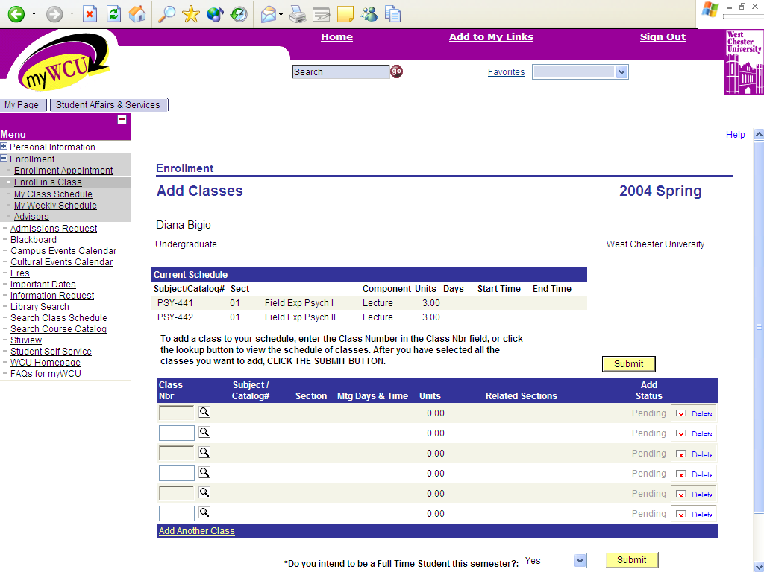

- When scheduling a lecture with a lab, make sure you add the lab!

- Click on the magnifying glass when you need to search!

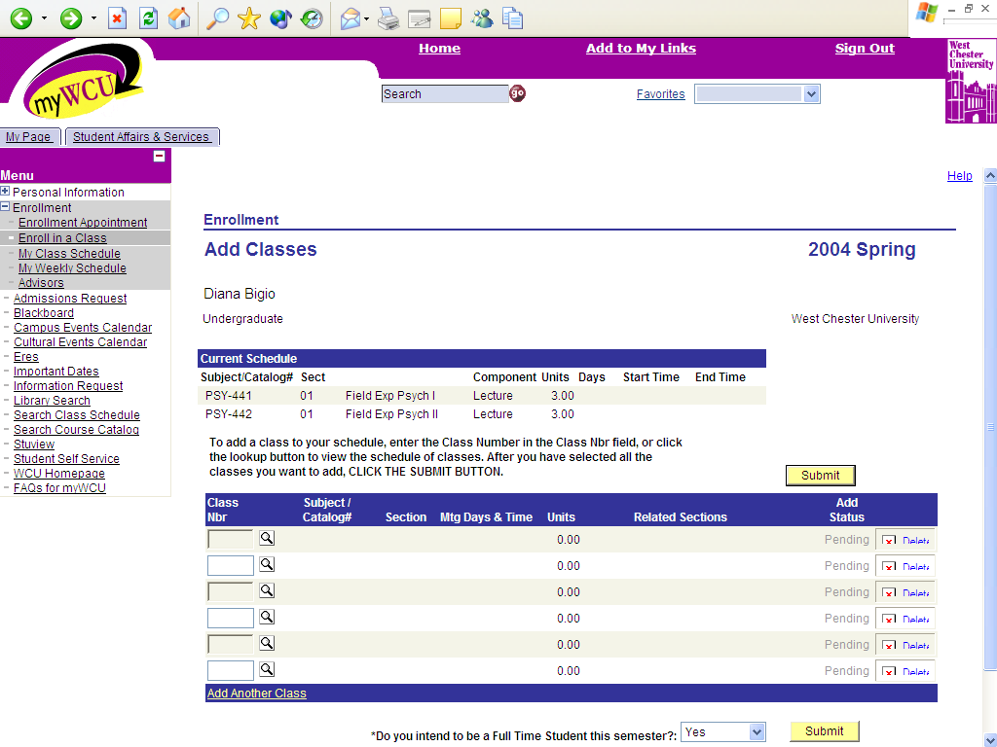

- Use the drop down box on the Class Search page to search by Diversity, Writing Emphasis, Interdisciplinary, etc.

Don’t use the “Back” button while you are in the enrollment pages. You may lose your work if you have not submitted your classes!

Remember to SIGN OUT of myWCU when you are finished! 